

Fixing HR
An Economic Analysis of 30 Thought Leaders’ Best Practices + Detailed Blueprint for the New Economy

Fixing HR
An Economic Analysis of 30 Thought Leaders’ Best Practices + Detailed Blueprint for the New Economy

Executive Summary

The work of an HR executive seems to never be done. This report, analyzing 5 years of findings and advice of 30 thought leaders in the area, suggests that perhaps HR has too many responsibilities and has lost its ability to be an effective resource to the organization. This report presents a detailed blueprint for identifying and redistributing the value drivers in HR with long-term effects nothing short of revolutionary: the transformation of Human Resources into a profit center instead of cost center.

Framed with demographic and historic social trends, this report further refutes the emergence of “The War for Talent” and offers innovative ideas on shaping the talent management model and value-chain framework accordingly, (including a fresh perspective on why organizations experience innovation bottlenecks.)

Read time: 1.5 hrs Figures: 10 Visit our HR service site: alberrios.com/when/ob

al berrios & company Report

© 2005 All Rights Reserved. al berrios & company, inc.

For information or permission to reprint, please contact al berrios & co. at:

One Liberty Plaza, 23rd floor
New York, NY 10006
(917) 744 - 6579
www.alberrios.com/c/syndicate.html

Foreword
November 2005
Dear Executive,

What you hold in your hands is a crystal ball which may very well influence the dialogue on organizational structures for years to come. It is without exaggeration, and with great pleasure, that I present to you our firm’s groundbreaking study on organization, a work five years in the making.

The idea to review other studies originated from an epiphany: everything that could be said about HR has already been said (and with some exceptions, to mostly negative reception). But, what is everyone saying? And had anyone actually said anything new or of value? When I presented some ideas from this report at two recent HR events, it was dramatically apparent that this topic had struck an impregnable (emotional) brick wall and offered an intellectually tempting opportunity to present an equally dramatic proposal for shaking things up that didn’t simply build on top of existing problems.

So what did we find? The most startling thing was that the HR function “kinda-sorta” grew organically, but never actually grew up. HR sprouted from senior management’s need to delegate menial administrative tasks and has since suffered from a chronic lack of attention (or interest), and consequently, innovation. If the Executive Summary whetted your appetite, keep reading and I guarantee you’ll learn something new.

We took tremendous care in avoiding any client name-dropping or showing any particular thought leader preferential treatment, and selected (and even improved upon) the most practical ideas of the last 5 years. You can rest assured that despite the enormity of transforming your entire HR structure, nearly every idea is actionable, tried, and tested. In fact, al berrios & co. is a viable commercial example of the organizational structures proposed herein.

I hope you find this read timely and enjoyable, but more importantly, applicable to your organization. My team and I are here to offer you continued guidance in this area.

“Resourcefully” yours,
al berrios & co. is an innovative strategy consulting firm advising leaders on the impact of human behavior on their strategies and on how to change their organizations to address the behavior. For more information, visit alberrios.com.



Al Berrios
Managing Director
al berrios & co.

P.S. In its current state, the things that can be said about HR can fill a book (or 10! But ask yourself, “Why” when HR is still just one area of management?) This report addresses nearly every major HR issue broadly. For specific applications and our views on ideas dating back more than 5 years, visit our HR service site: alberrios.com/when/ob

Table of Contents

HR In Context - A Brief History 5
Figure 1: A Shifting Economy Shifts Faster 7

What You’re Paying Your Consultant For 8
Figure A: Validity of Research 8
Figure B: Perspectives Presented 9

The Demography of the Labor Pool 10
Figure 2: Comparing Ideal (Employee Conditions) and Current 11

Blame Yourself For An Incompetent Workforce: On Educating and Unionized
Workers 11
Figure 3: Traditional Approach to Human Resource Management 12

Choking On Innovation 13

Who Should Own Talent Management? 14
Figure 4: Decomposing Jobs Into Tasks 15

Obliterating The 40-hour Week: The Insourced Organization 16

“Talent Collectors” Are the Only Ones Fighting “The War for Talent” 17

The Future of Managing Talent – Best Practices 19
Figure 5: Proposed Adaptive Talent Management Cycle 19
Figure 6: Traditional Approach to Value-Chain Collaboration 21
Figure 7: Proposed Decomposed Value-Chain 22
Figure 8: Thought Leaders Advocate 25

Compensating Workers According to this Model 26

Leadership, Culture, and Implementation 26

Conclusion 28

Methodology 29

About The Author 32

Notes 33

HR In Context - A Brief History

Imagine it’s the 1850s and you’ve just arrived on Ellis Island with your family from your country. Like your fellow countrymen, you came to America for a better life; where every man is his own master. After monarchism, where your life belonged to kings, what more precious gift is there than freedom?

Your goal is to go West, where you’ve heard land is plentiful and free, and you keep what you sow. Scrounging, struggling, hungry, cold, and exhausted, you take your family as far as Pennsylvania, to a clearing by a river near Titusville.

As a farmer in the 1850s, your “business” is simple: your home is your organization, of which you’re the CEO/COO/CFO, your kids are workers, the oldest being your line managers, and your wife is head of HR/Facilities. Your parents are your board of directors and costs are measured in time during daylight hours. Your “career” goals are simple – keeping your family alive. Life is hard on a farm in the 1850s, but glorious for exiles of an aristocratic age that treated them like their lives were worthless.

In 1858, oil is discovered in Titusville. Your whole business is about to undergo the most dramatic upheaval of its life. You have inadvertently been caught at the cusp of an actual economic shift and you’re unprepared, to say the least.

Your land quickly becomes overrun by speculators, building rigs (sometimes legally) on any clearing. Yours is soon targeted. Speculators fill your head with incredible fantasies of wealth. Your board is too conservative to give you the right direction; your HR head is telling you she needs more resources; and you’re looking at the bottom line. Time to sell.

You collect your belongings, family, and tidy sum for your land and head further West. But it’s too late; everyone’s headed East, where earning a living with a factory job is easier than farming, and the collection of so many people naturally generate the sort of excitement where one can divert themselves a million ways. Your organization wants to be part of that world.

Welcome to the industrial age. As the son of a farmer, working for Standard Oil in 1910, your “business” is simple: take orders, get paid. Motivation, benefits, a weekend off, a safe environment, inalienable rights, none of it is provided by Standard Oil. You don’t mind being part of such an organization because it’s huge and they pay so much more than your parents ever earned farming. But it’s not easy work and you’ve seen many of your co-workers die on the job. Someone somewhere compares it to being ruled by a king and decides they’ve had enough. The concept of labor vs. management, rooted when you were still a boy on the farm, has reached your organization. Before long, you’re swept into the frenzy and something unexpected happens; Teddy Roosevelt listens. He tries his darnest to help by breaking up Standard Oil, and succeeds. In 1912, trustbusters break up the Octopus just in time for Ford to invent the gasoline powered automobile. Standard’s success at efficient production and distribution make gasoline cheap. Ford quickly ramps up production, hiring thousands (including you), and realizing that his workers are the key to his success, offers everyone great pay and a 5-day work-week (the closest things to benefits). You express your loyalty by buying Ford autos, insisting everyone you know buy them, and deciding you’re a Ford man for life.

As an upwardly mobile worker of the Roaring Twenties, you’ve been poached from 3 different financial companies, and each time, your pay increased. Your pop, a die-hard Ford machinist, doesn’t understand how you can make so much without actually doing anything. In 1929, you and your buddies on Wall Street took the whole country into what they call a Depression. You get fired, and since you’ve never saved any money, you freak out and move back in with your pop. Your co-workers are killing themselves – literally – and although you don’t yet realize it, the next 6 years will be your hungriest. Your high-maintenance girlfriend will leave you. Your parents will pass away. And your only option will ultimately be to sign up to the military. FDR starts passing laws to help employees – how they’re treated at work, their rights, and most importantly, figures out a way to keep us getting paid after we stop working. The man’s a genius!

It’s 1946 and industry is thriving with American supremacy in the world. Exhausted, (yet frisky) soldiers are everywhere, ready to settle down and forget the horrors of war. Thanks to the proliferation of “management consultants” (accountants and lawyers applying their know-how in the once-derided business world instead of the “serious” world of politics), the owner/manager are becoming two different roles. And thanks to all these laws and workers and jobs within the same organization, an administrator who can keep track of it all is required. The entrepreneurial spirit, once the force behind industrialization, has been left behind on the battlefield, steered by a paternal government looking for ways to get the whole country out of the Depression. “Command-and-control” is the survival mechanism embedded into the heads of many young men and women, and the Government is trusted completely. It was a Brave New Deal.

In the 1960s and 70s, cheaper printing, widespread telephones (Thanks, Ma Bell!), radios, televisions, and cheaper and cheaper automobiles (Thanks, Ford! Thanks, Rockefeller!), have brought the country closer together, despite spreading it out further. Industry tracks government, and grows exponentially, unabated. Urban sprawl leads to suburbanization, and career stability is mantra as the social agenda “matures”. And for the first time in the world’s history, corporations begin replacing government as the dominant form of organization; HR inexorably takes on new powers.

Somewhere along the way, we fight the Russians, fight for our Civil Liberties, fight in Korea and ‘Nam, fight Big Brother, and fight alongside a “Thrilla in Manilla”. And everyone was tuned in.

It’s the 1980s and 90s, and we’re tired of fighting; it’s time to rock and roll. Business is booming and workers continue to want more rights (the nerve!). Management doesn’t mind obliging, since everything’s “go-go” and they’re getting paid disgusting sums of money. They’re also spending so much time on the golf course, they’re hopelessly disconnected from their workers, depending heavily on HR. While everyone was partying, though, something was happening to the economy. It started to shift, finally. It had been so long since the last shift, no one noticed that transactions became global, technology shrunk the world, and you, a peon of corporate America became re-ignited with something that hadn’t reared its head since the days of your great-great granddad – ambition. Irrational ambition (and unlimited access to anything at your fingertips) drove a pile driver right through the 20th century. And while professional management was living it up, we entered the Information Age, the Service Economy.

Figure 1

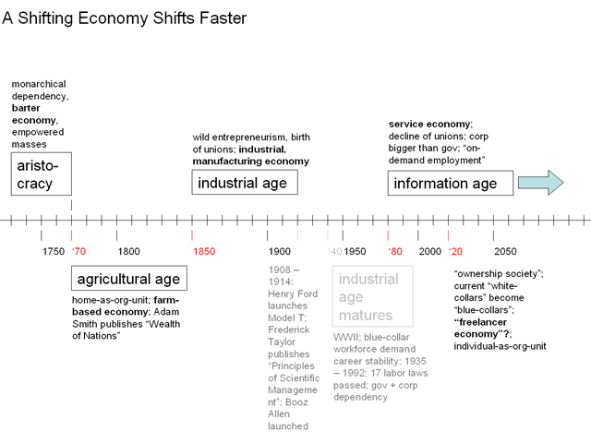

Today, as CEO of your own entrepreneurial venture, your funniest joke may land you in court for sexual harassment, the mercurial CEO you’ve always wanted to be is now the FBI’s most wanted, and your pay hinges on how warm and cuddly you are with everyone within spitting distance. HR, still living in a world where Big Auto hasn’t been downgraded to “junk”, defy reality and treat you like they used to treat your granddad. But in your granddad’s day, you were loyal to the company. Today, you’re loyal to your co-workers ⁽¹⁾. How an organization defined the person is changing to how the person defines the organization. Ironically, your HR folks know this before every interview (think resume), but they don’t value new talent by the value of their individual output; instead, it’s their flexibility in contorting into an intricately and lovingly worked-up org chart that they relish in every fresh body. Unbeknownst to them is that in this age of information, they should let your line managers and lieutenants recruit and hire, while they manage loyalty to their former co-workers in new and creative ways (think deal-flow and referrals to new business). Welcome to a new age. Now that we’re all here, let’s explain how it works for the new Human Resources.
What You’re Paying Your Consultant For

Few things are pricklier than critiquing the work of a fellow researcher. So, this discussion will instead focus on the general authority of their advice, often misconstrued to be top-notch merely because it comes from a particular source. To do away with this first myth, note the skewed preference of researchers to use easier-to-get qualitative data over more statistically sound quantitative data, and even less utilization of outside sources (Figure A). (Disclosure: quantitative research from this firm is included. We advocate all three, and encourage executives to look for use of all three from their advisors.) What this suggests is a potential deficiency in their analyses and advice since there’s an obvious lack of data, almost inexcusable in this Information Age.

Standard practice dictates that consultants evaluate the senior executive perspective in nearly all research and there were no exceptions among researchers reviewed here. But perhaps the reason consultants offer little innovation in the HR function is because they’re spending too much time spotlighting their access to senior executives in your industry and their ideas instead of analyzing their workers’ behaviors (Figure B). Surprisingly, despite this and being free, just 73% of consultants presented proprietary metrics, frameworks, and solutions to dealing with problems (real or not) in managing a workforce. (Continued on next page.)

Figure A

What You’re Paying Your Consultant For (cont’d)

This lower-than-expected number isn’t an increase in the general beneficence of your consultants: in the opinion of this analysis, most HR thought leaders don’t really think, regurgitating stats out of context, alarming executives to emulate peers, and presenting incomplete perspectives on solving problems (i.e. “Companies must motivate employees.”)

If the reader were to review each one of these thought leaders (averaging 18 pages each of eye-glazing consultant-speak [excluding books]), they would walk away from the experience fully agreeing that the problems cited all exist, but none-too-satisfied with the disconnected ways to address them.

For example, there were an overwhelming number of client names and case studies liberally peppered for the sake of illustrating how those problems were solved by the authoring consultancy. Unfortunately, they were more marketing than thoughts, with very little resembling innovative thinking on addressing problems in HR.

And for the record, HR “experts” really are some of the most painfully dullest writers around.
Figure B

The Demography of the Labor Pool

Somewhere between 13 and 17, our kids got dumber. Thirteen year olds’ ability to understand complicated information has improved since the 1970s, but as they got older, their ability to “interrelate ideas, make generalizations”, and form opinions diminished ⁽²⁾.

“In October 2004, [just 67%] of high school graduates from the class of 2004 were enrolled in colleges or universities” ⁽³⁾.
“Somewhere between 13 and 17, our kids got dumber.”

And of those that actually went to college, it’s expected that just under 27% will graduate with a 4-yr degree ⁽⁴⁾.

These figures get worse the more rural or ethnic students are. Ironically, in 2001, national per pupil government spending for Fall enrollment reached $7,503, a 20% increase since 1988 (when students were smarter) ⁽⁵⁾.

Surprisingly, “of the 16.3 million 16- to 24-year olds not enrolled in school in October 2004, [81%] were in the labor force.” ⁽⁶⁾

Does this mean you don’t need a college degree? Practically, since college grads are just 1.09 times more employable than high school grads ⁽⁷⁾. (It’s only if you don’t graduate from high school that your odds diminish drastically, although, you can still get a job somewhere.)

Incredibly, a whopping 55% of small businesses (between 5-250 employees) require no education or high school degree/GED in order to fill their “most skilled job”. A larger still - 73% - don’t require education or high school degree/GED for their “most common job” ⁽⁸⁾. At least 85% of employers in the U.S. are small businesses ⁽⁹⁾.

You already know what all this data says. Anyway you slice it, it tells the story of a labor pool that has little, if any, incentive to learn or love to learn. Worse still, this is a workforce that doesn’t particularly care about working or the employers they work for.

A 2004 worker sentiment study by this firm revealed that 18% of your workers hate their jobs ⁽¹⁰⁾. An emotional connections study by another firm found that workers are more interested in seeing more results (presumably for more praise and rewards) for doing less and less work ⁽¹¹⁾ (Figure 2). Larger employers put the onus on politicians to spend more, prepare better (to work for them), and light fires under pants, without recognizing that the problem is actually their own lower standards and poorer management of their own workers.

You were welcomed to the Information Age. Now welcome to the real United States of America in this Age. Is there any wonder why jobs are being offshored?

Figure 2

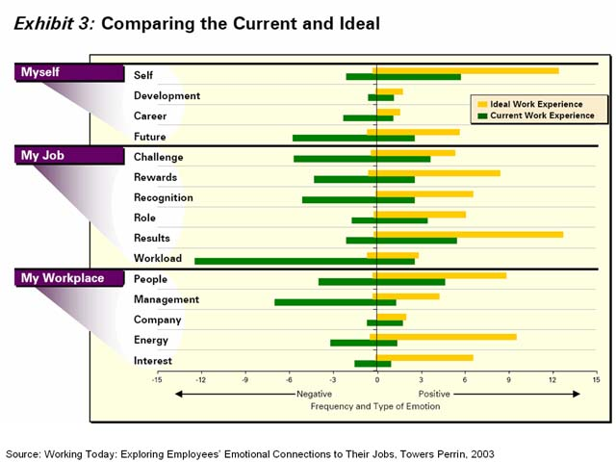

Blame Yourself For An Incompetent Workforce: On Educating and Unionized Workers

Assume economist Friedman was correct and companies are in “the business of business”; and consequently, to make money. If you assumed that it is owners who make this money, congrats; consider yourself a bonafide economist. But consider this: without raw materials, inventory, and/or the services of other humans, would an enterprise really be a sustainable business? You outsourcers are thinking, “Of course”, but the real quandary behind this question is whether or not a business should only exist to make the most money for owners, relegating all others to receiving crumbs, despite their critical role in the money-making process.
“As the name implies, legacy costs have always been there, when the company was profitable and when it lost money; the only thing that’s changed is management.”

Owner managers figured out a long time ago that regardless of all the resources marshaled for the effort of making every cent, all those pennies belong to them. When professional management took over, there was no mistaking the relationship for what it was: they worked for the owners and got paid to do a job. To this day, their direct relationship with owners gives them a superior advantage to common workers. But what about these common workers? And that’s how “their” side of the debate actually makes sense: the true purpose of unions is to avoid being treated like a piece of equipment, and to be treated like true participants in the earning power of the entire organization.

Plainly stated, an undereducated American labor pool is the fault of employers themselves. Workers are highly productive (thanks largely due to the 100-year old industrial economy perspective), but uninnovative in a new “service” economy, where information, knowledge, and ideas are the real currencies; and unambitious, as every conceivable safety net has been cast to eliminate risk and accountability from everyday consequences – from welfare to the return policy at the store. Add to that an underinvestment in training ⁽¹²⁾ and a linear HR structure (Figure 3) that churns a diminishing pool of eligible workers, and sounding the alarm seems like the right thing to do.

Figure 3

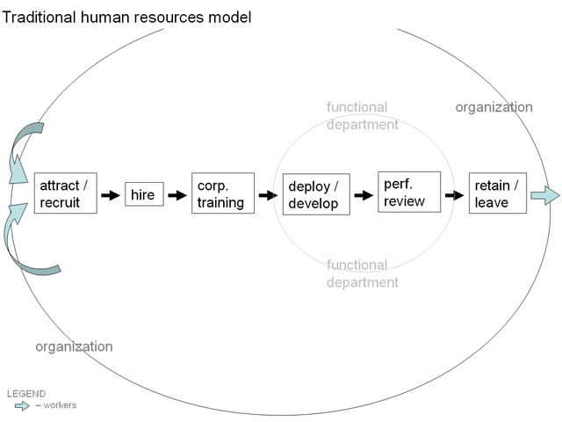

Why should you spend between $0-$1000 per year to educate anyone you’re already paying and offering benefits to? ⁽¹³⁾ Moreover, in a recent analysis by this firm, no correlations between corporate universities and low turnover rates were obvious ⁽¹⁴⁾ meaning that they can take their corporate-sponsored knowledge and your trade secrets to your competitor. How can anyone justify spending any more money on already costly workers to make them more attractive to your competitors and less likely that they’ll stay?

The problem is still employers. Their training is sub-par; their utilization of worker knowledge (knowledge management) is “sub-par-er”; and there’s still a perception that every penny spent on such a “risky” investment as worker improvement (particularly in this day and age of global sourcing) is money directly from the owners’ pockets.

Returning to the above-mentioned premise that organizations could possibly exist for the maximum enrichment of everyone involved in generating earnings, not solely the owners, unions exist to represent regular employees to the owners, in lieu of their relatively low status in the hierarchy of enrichment. Without the coordinating powers of unions to look out for their basic interests (job security, minimum standard of living, general quality of life during and after they retire), common workers would become dumber, outsourceable, and ultimately, unhirable. Imagine an economy with 15.5 million unemployable workers – that’s the total number of currently unionized workers today, potentially a nearly 17.4% aggregate national unemployment rate ⁽¹⁵⁾. Big Auto may be bleeding cash supporting tens of thousands of worker pensions and healthcare costs, but their failing as a profitable enterprise has nothing to do with a costly union workforce and everything to do with dearth of management prowess. As the name implies, legacy costs have always been there, when the company was profitable and when it lost money; the only thing that’s changed is management.

Choking On Innovation

Among large organizations, just one large (beverage) company has publicly admitted their poor performance is substantially due to incompetent workers ⁽¹⁶⁾. Among the various deficiencies, one stood out: little innovation. Companies complain regularly about not being able to innovate quickly and consistently, but why have so many organizations found it so challenging?

Consider that nearly every organization has a suggestion box or some mechanism for capturing ideas that can turn into money savers and money makers. What’s the motivation for a common worker to think for the company? A piece of paper saying “In Recognition Of”?
“If thinking for you will ultimately diminish [an employee’s] value outside of your organization, why bother?”

Now consider that scientifically/academically-focused organizations are often highly competitive idea factories, tripping over each other to churn them out. The incentive is no secret: the opportunity for infamy as a real-life patent holder or Nobel laureate. The disparities between how scientific workers and common workers are motivated to think for an organization couldn’t be starker.

Consider also that your greatest asset’s greatest asset is their relationships and ability to produce some valuable output from them. But when they leave your organization, those assets somehow become the organization’s assets.
“valuable output can only be achieved at the discretion of the talent, and they have equal claim to that output.”
In both cases – knowledge and relationships – the notorious “non-compete” mentality flatly denies your workers the right to claim that they may be of any value to any other organization. If thinking for you will ultimately diminish their value outside of your organization, why bother? In hoarding this intellectual property, it also prevents the organization from innovating itself as it attempts to preserve this artificial short-term monopoly. On the one hand, organizations attempt to encourage innovation among its common workers with incentives that recognize innovation achievements internally (i.e. promotions, raises). On the other hand, it’s these very incentives that also hamper (or even prevent) innovation by limiting (or sometimes prohibiting) worker mobility since their achievements are untransferrable to other organizations (i.e. a worker must rebuild credibility from scratch and/or risk starting at a new organization at a lower position). Thus, it is organizations’ HR structures that stifle innovation and alienate future opportunities for business by missing what motivates the typical worker (not always direct monetary rewards).

Who Should Own Talent Management?

Few things in this world are as intoxicating as the authority to hire another person. In fact, one of the most persistent metrics of HR performance is “head count” ⁽¹⁷⁾ (despite its irrelevance). And therein also lies one of the biggest challenges to effective talent management – the misperception that overseeing talent is more critical than overseeing the tasks that are essential to the organization’s success. This misperception occurs because after hiring talent, HR does not actually manage it. Thus, this report proposes to maximize utilization of all workers by removing the function of managing talent, including recruitment, hiring, training, and management, from HR and redistributing it throughout the organizational structure to the managers who will ultimately end up utilizing the talent.

Practically speaking, this has the potential to create silos of power or “divisional hoarding” within an organization (i.e. does the talent work for an individual line manager who claims the worker relationship as his own or the organization who is disconnected from the relationship, but considers the talent an asset like any other under their disposal?) However, recalling the ideas presented in the “Blame Yourself” section, it is important to recognize that the asset isn’t the relationship, but the output of that relationship. As a result, in the case of talent, valuable output can only be achieved at the discretion of the talent, and they have equal claim to that output as the organization.

To exploit that output to the mutual benefit of both the organization and individual talent, a job can be “decomposed” into several tasks (Figure 4), so the value of the entire chain isn’t dependent on a single critical individual doing his/her job right. (Note: Many “blue-collar” jobs are already tasks, not jobs. But like in other areas, HR has not significantly innovated on how it manages these roles).

“Decision rights” rationing and forfeiting (when not acted on within given time frame) per individual ensure success of task completion and prevent wasteful meetings to align individual outputs. (This is comparable to a simplified software environment, where all outputs are like building blocks, no output being critical to the whole). Tracking and enhanced output-evaluations (performance reviews) diminish errors by preventing erroneous output from being attached to the whole.

Figure 4

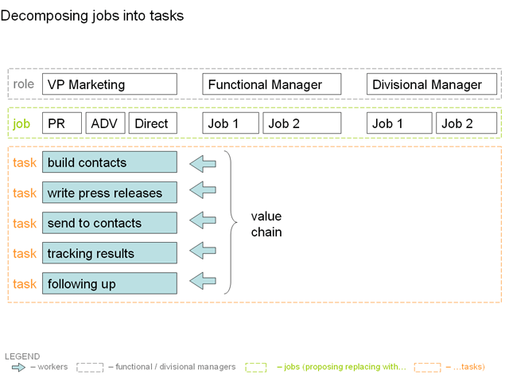

To determine what an organization would look like under this model, take its total headcount and multiply by 15 – an average estimate of tasks per job. This exponentially larger and more sprawling organization appears as though it has more layers and is less transparent. But a natural occurrence of decomposing is accountability being pushed down to each individual worker, not hodge-podge teams of conflicting divisions with functional priorities. Subsequently, an organization’s leadership will spend less time supervising, relying on talent self-governing itself, and spend more time coordinating and executing strategy. Organizational leadership is also assured natural controls and risk limits with decision rights rationing.

Note that in a world where every worker has the right to benefit from their output, this “freelancer economy” (projected above in Figure 1) begins to take shape. With everyone packing valuable “assets”, our society will continue its transition into a society where everyone is selling (a.k.a. consumerism) and service is the differentiator.

Obliterating The 40-hour Week: The Insourced Organization

The output of an individual talent isn’t uniformly valuable during a continuous uninterrupted “career” within the same organization (putting into question the long-held belief that long careers are beneficial to the organization. In fact, the longer the tenure, the more entrenched the status quo [recall “Innovation” section]. But you already knew this: the expression “same sh**, different day” has been summing up the monotony and utter lack of stimulation of daily routine very vividly for years).

This firm’s behavioral research has shown that no matter what they’re engaged in, human beings have a lifecycle for it – whether volunteering, working, or executing recommendations in this analysis, there is a limited time frame that a person is most productive.

This timeframe is the length of the lifecycle and operates in spurts, not indefinitely or consecutively, lasting usually until the conclusion of the task to be completed, but can be activated (it deactivates over time, almost immediately after the end of the task and upon deactivation, all performance metrics decline).

What activates the lifecycle is a purpose or goal that needs to get accomplished. The “rewards” for achievement are a) the right to co-own and benefit from the output while in a transitionary downtime period (i.e. paid time-off), awaiting the next assignment; b) the right to own their own time (i.e. flexible scheduling); and c) recognition. The “recognition” is derived from peers, not awards. It’s why resumes exist and defines their value to the next goal. The concept of “idle” workers is derived from idle assets, without taking into account the output of those assets. The piece of equipment isn’t the asset, but rather, its output. Since equipment can work continuously to maximize its utility, on paper, all assets work the same way. Clearly, humans don’t work that way and this report suggests exploring scheduling outside of the traditional 2-day-per-7-day break and 9-5 scheduling in an effort to maximize the output of talent. Contrary to traditional management thinking, which assumes, mechanically, that workers are all tired simultaneously after 8 hours without taking into account whether they feel they’ve accomplished their task or not, this analysis proposes managing talent scheduling (of every type) by not managing and letting them manage their own schedules (with parameters set by organizational leadership).

(A further innovation may take the shape of a “grid-employment” model that utilizes the idle time of someone else’s workers in the same way computer grids are formed from the donated idle time of other people’s computers to complete different sized tasks around the clock. Note that gradually, workers will seek to offer their valuable output to other organizations, forcing organizations to manage frictionless worker mobility in the same way they market to and manage relationships with empowered consumers.)

Talent “Collectors” Are the Only Ones Fighting “The War for Talent”

According to Workforce Management Magazine, there are at least 74 distinct responsibilities the human resources department is “accountable” for – everything from attendance to wrongful discharge. Then there are those extras, like managing org charts and notary public services.

One of the most hot-button responsibilities of the last 8 years (yes, it’s been that long since the following phrase was first used), has been dealing with “The War for Talent”. A review of 30 studies, books, newspaper and magazine articles, trade shows and websites, and academic and government resources reveals that there should be no such thing as a war for talent in an Information Age. And if there were, anyone engaged in this war is an unwitting grunt in a Sisyphusian struggle.

Before you go into raving hysterics opposing the validity of this statement, consider that as surprising as it may sound, there was only one originator of the phrase, with every other assessment parroting the same findings. Moreover, it is the belief of this analysis that the demographics used (in 1997) have been taken out of context considering:
“As the economy shifts, the most skilled jobs gradually become common jobs and the pool of workers able to perform it increases.”

a) every decade, particularly the late 90s, has a ramping up of hiring and survives just fine with the available labor pool;

b) the regurgitating doesn’t take into account two separate functions – hiring and actually managing talent, an overlook that grossly skews the whole picture; and

c) recruiters of top talent fall into a well-studied trap of competitive bidding, but never applied to recruitment – the winner’s curse. In essence, the curse is overvaluing and overpaying based on experience biases, substantial lack of information (i.e. what other organization has offers on the table?), and unknown variables about the value of the output of the talent given your resources and changes in strategic direction.

Consequently, based on the need to compete for bodies with brains to fill jobs which are supposedly fixed on organizational charts, recruiters create high valuation bubbles for these specific skills and jobs, transforming previously common workers into “talented”, poachable mercenaries. This distorts the true costs of recruitment and retention and severely impacts an organization’s ability to invest internally on training talent ⁽¹⁸⁾. Worse yet, the organization becomes not a manager of talent, effectively utilizing workers for maximum valuable output, but a collector of the cream of the crop, continuously hiring them at the highest bid without truly evaluating their cost and utility within the organization. Ask yourself, who picks top players for sports teams? HR? And once picked, are teams off to pick the next player or manage the one just acquired?

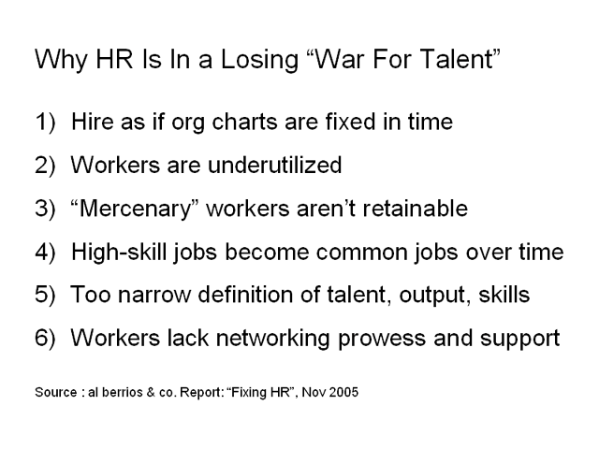
The first misconception here is that the current stock of workers, top notch or otherwise, can only handle limited workload. Although workers prefer to do less work (as cited in Figure 2), that’s generally because the work they’re getting isn’t matched to their most current profile (as evidenced by a maturing tech industry, ^{[19]}). Poaching then occurs because talent isn’t utilized to their satisfaction.

A second misconception is that pay, bonuses, and benefits will retain top talent. Branding attracts them ⁽²⁰⁾, but nothing keeps these mercenary workers.

A third misconception is how senior executives mistakenly believe many of the jobs in their organization can only be performed by a few highly skilled workers who are able to “hit the ground running” wherever they land. As the economy shifts, the most skilled jobs gradually become common jobs ⁽²¹⁾ and the pool of workers able to perform it increases.

A fourth misconception with this “War” is the narrow definition of talent, output and skills. Despite the value of “experience”, older workers (55+) are not generally counted as part of workers to be fought over. “Nearly 40% of workers think that employers begin to view a worker as old by the age of 50.” ⁽²²⁾ People retire from companies, not the economy. Moreover, knowledge doesn’t retire. “Nearly 7 in 10 American workers report that they plan to continue to work full- or part-time for pay following retirement from their main job. Another 14% plan to work as volunteers. Only 13% of employees expect to stop working entirely.” ⁽²³⁾ In 2004, age discrimination was the third highest charge submitted to The U.S. Equal Employment Opportunity Commission after Race-based and Sex-based discrimination ⁽²⁴⁾. It’s a tactical error to regard retirement as “death”, especially in an information economy.
“People retire from companies, not the economy. Moreover, knowledge doesn’t retire.”

And despite the lower costs of more dependable workers such as candidates with disabilities – statistically proven to be more reliable as a group than workers without disabilities, with no additional costs – they are also not counted. Recalling that in the “Demography of the Labor Pool” section, 85% of the businesses in the U.S. require only that candidates be able to fog a mirror to work for them, it’s surprising that “nearly one-third (32%) of employers say that the nature of their company’s work is such that people with disabilities cannot effectively perform it.” ⁽²⁵⁾

The Future of Managing Talent – Best Practices

Let’s define “talent” not by the job HR needs to fill, but by the candidate’s capacity to produce valuable output with an organization’s resources. Let’s define “output” not by the hours talent works or number of relationships they have, but by their ability to complete tasks or their ability to monetize those relationships. Let’s define “skill” not by their attitude and proficiency with software and hardware, but by their success in their overall performance for the organization they’re engaged by.

In the traditional linear human resources model (Figure 3), organizations essentially pull workers in, chew them up, then spit them out. HR’s lack of direct interaction with the people in the organization is the equivalent of a sales associate who just opens the store, leaves, then returns at the end of the day to lock up. In every study, article, and report reviewed for this analysis, elements of a more adaptive talent management cycle are suggested, (Figure 5). The purpose of this report is to connect the dots in context. Presented here for the first time:

Figure 5

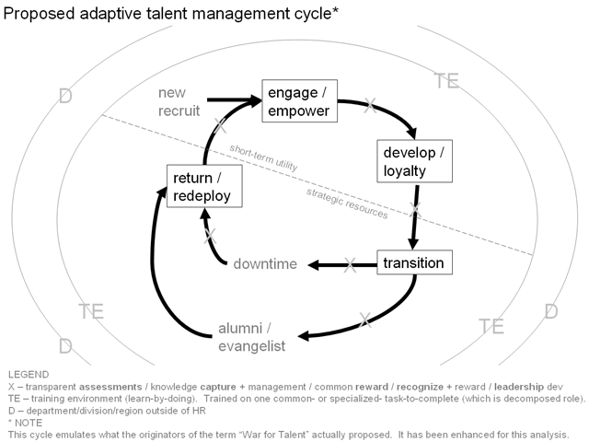

a) Transferring Accountability for Training From HR. One of the most controversial differences between the traditional and proposed approaches is the transfer of accountability for training from HR and to the functional and/or divisional area of talent. If a worker is poorly trained, someone must be accountable, and if HR isn’t working with this individual on a day-to-day, HR shouldn’t be expected to take responsibility for that worker’s training.

b) Training. Immediately recognize that at least 70% of new hires are unqualified to fill a job in the new economy. Consequently, training – even for the most common tasks – is much more critical than organizations have traditionally believed. Training isn’t done in a vacuum, but in an environment often referred to as learning-by-doing (a.k.a. “on the job” training, and in more current consultant-speak, “action” learning). Training can occur person-to-person or peer study groups, from manuals or online curricula, or even a third party (i.e. suppliers or customized, degree-granting curricula at academic institutions), but should integrate all of these in an action learning environment. (How effective can retention be if workers feel organizations don’t care enough about them to invest in training them to be better workers?)

c) Engaging and Empowering: Introducing New Project Workers. There are 4 proposed dedicated project worker roles that collaborate to complete value-chains utilizing organizational resources: The project networker (PN) is empowered with decision right over coordinating internal “talent networks” (of affiliated and non-affiliated workers, explained below in “Transition” phase) from which the project sourcer (PS) solicits workers (workers enter talent networks from functional and divisional areas) who’ll eventually complete tasks. Workers are solicited (like customers) for their participation based on their “dynamically updated profiles”. While PN prevents workers from getting pigeonholed (stunting growth within the organization), PS ensures that too many high performers won’t all be engaged on the same projects.
Check out our Reports on networking:
- “The Metrics Of Professional Business Networking”, http://www.alberrios.com/c/0805.html

- “The Economic Theory of the Professional Networking Group”, http://www.alberrios.com/c/0705management2.html

The project decomposer (PD) decomposes value-chains, assessment benchmarks, and decision rights (accepting a task empowers a worker with its decision right, eliminating opportunity for favoritism). PD decomposes enough to ensure rapid completion of each task.

A challenge may appear in passing on cost of performing a single task on to clients or customers, however, since a decomposed job has superior cost visibility, an organization subsequently has greater pricing power. The value of project determines the value of each task; the value of the task determines the maximum cost it can have to complete. The project coster (PC) aligns the project’s costs with how much value the organization can derive from it.

Workers are empowered with decision right to join networks, select task to complete and its output ownership, and move laterally and vertically throughout organization. This is how “divisional hoarding” risk is eliminated (recall “Who Should Own” section). As a worker’s outputs increase in value to different tasks across different organizations, they “ascend” in their status and level, fulfilling their perception of career advancement.

Functional/divisional managers sole purpose is to manage the process of recruiting, hiring/firing, training, and supporting workers as they transition between project tasks (Figure 7). (For the purposes of this report, the term “value chain” is interchangeable with “project”.) Note that this model integrates new workers into an organization on the organization’s timetable, guaranteeing nimbler response to opportunities.

Figure 6

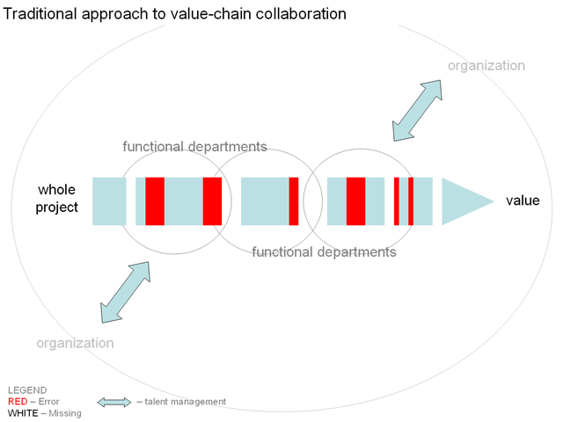

In this model, every project has a quantifiable value arrived at by decomposing it into its component tasks (including getting coffee). There are two general types of tasks to be completed under this proposed model: low-value and high-value tasks, with variations in between. Project leaders (PL) are senior executives empowered with decision right of authorizing value (i.e. compensation, rewards. See “Compensating” section below) to projects and tasks (not workers). Accepting a task grants worker the opportunity to own and derive value from task completion (whether as direct compensation or ongoing value).

All talent is assessed and invested on similarly (it’s up to the talent to enhance their own value at their own pace) and are accountable to the entire organization for not completing their task, not a friendly line manager who will hide or excuse their mediocre performance. Every worker within the organization is accountable for completion of at least one task for the organization at a time.

If there are no takers for a task, PLs may modify value, PDs may alter task composition or decision rights, PSs may source from deactivated or non-affiliated talent, and if all else fails, leadership can authorize termination of value chain.

d) Development. The development phase is probably the most crucial to the talent management cycle. This is the phase where talent is assimilated into the organization through mentorship and internal talent networks and will facilitate subsequent phases of the talent management lifecycle.

Figure 7

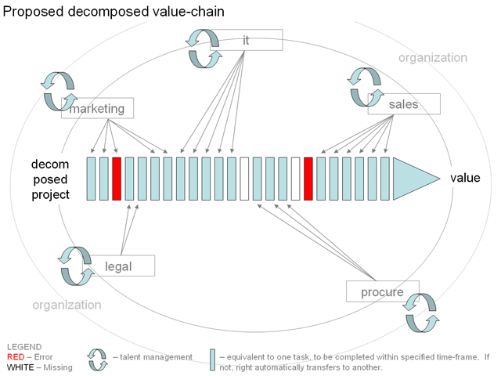

This phase acknowledges that many workers are poor networkers and poorer promoters of their own potential and ambition, limiting their professional advancement. Workers who do promote themselves get all the attention and everyone fights over them, supplementing this report’s argument that there isn’t necessarily a lack of talent, but, to add to our examination opposing this perspective, there also appears to be a lack of networking prowess among workers in general.

Because the completion of a task isn’t expected to take very long, the Engagement and Empowerment and Development phases of this proposed cycle are ideally short-term. To assure that a worker doesn’t intentionally delay or isn’t sufficiently qualified, all tasks come with expected time-to-complete windows (as shown in Figure 7), after which, if a worker fails to realize the output from their completed task, their decision rights are forfeited to another worker. At no point would successful achievement of the goal be imperiled due to a single worker not completing their individual task.

e) Transition. The transition phase of the cycle is where a worker who has completed their task decides to either remain affiliated with the organization or exit to another organization. Should they decide to remain affiliated, that worker will deactivate until the next task is presented, enjoying well deserved “R&R”, as suggested in “Obliterating” section. Should the worker decide to exit the organization, this report suggests that organizations provide outplacement support as a standard component of the talent management cycle (as opposed to a special benefit provided solely to senior executives) to find that worker their next task, internal or external of the organization – institutionalizing all their knowledge for use on future tasks. Organization will then regard that worker as an alumni, fully expecting that worker to evangelize on behalf of the organization for new business, talent, and knowledge.

At any point, should the tacit knowledge or output of that worker ever be required for other tasks, the organization would facilitate that worker’s return. In both instances, that worker will continue to be managed by the organization for the mutual benefit of both parties and more importantly, the need to retain becomes irrelevant, while simultaneously instigating a healthy, loyal relationship with the organization that appreciates and supports its workers, current or former, affiliated or not.

f) Return/Redeploy. Upon accomplishing tasks, the talent that’s active will deactivate for their “downtime” and the deactivated talent activates to accomplish the next project goal. The return or redeployment phase is the reactivation of affiliated talent and returning talent. Extremely relevant is this phase’s function in diminishing the organization’s dependence on less-than-qualified new hires and overpriced talent since the organization counts on talent they’ve already trained and remain loyal.

It is this phase that makes any worker ever trained or performed any task for the organization to be considered a resource for the organization, as opposed to an expense (i.e. pensions). By effectively managing talent networks, the organization can even cap the total number of workers it needs at any given time, eliminating the need for ongoing strategic staffing, crunch-time binge hiring, or even right-sizings and making the new hire process more selective.

g) Transparent Assessments, Knowledge Capture + Management, Common Reward, Recognize, Leadership Development. Note that between phases, it is important to assess each worker’s individual performance per task on a transparent scale known to all and unanimously fair in its approach, fair because expectation of output and its relevance to the organization is known to individual being assessed. That assessment should include knowledge capture and management. But most importantly, it must reward and reprimand when applicable.

These “performance reviews” are vastly different than traditional reviews as functional/divisional managers can benchmark against individuals in their division performing the same tasks (not jobs), as opposed to benchmarking against employees throughout the organization or industry permitting organization to act preemptively and decisively with low-performing workers. Talent is assessed based on task completion metrics (how fast, quality, relevance), facilitating the identification of the top talent to be utilized for greater roles within the organization.

Assessments work as follows: recall that PDs decompose task benchmarks into equally weighted components. As a worker performs and ultimately completes or fails to complete a task, their achievement is tracked along the benchmarks which are also dynamically adjusted with every additional worker being tracked. PNs input based on character of worker (based on interactions networking with worker); PLs input based on quality of work (based on utilization of worker output for value-chain completion). Functional/divisional managers’ input is based on recruiting, hiring, training, and measured across all other workers within division. A worker can input into system directly by tracking work times, progress to completion and completion time, task info, and knowledge gained. Capturing knowledge is actually done in two parts: in real-time as the task gets done (i.e. Wiki-format = “Workepedia”) and during the recognition, which encourages workers to document methodologies and processes used, both tacit and explicit. The entire system can keep workers individually updated on their assessments in real-time, empowering them to evaluate their own likelihood of completing a task and the value they would expect to derive. If they choose to stop prior to completion, another worker can pick up where previous worker left of without stunting work done for organization. (New worker would then assume decision rights and remaining value).
“This proposed adaptive talent management cycle attempts to turn HR into a profit center rather than a cost center.”
With this model, talent can easily identify their favorite or weakest areas of performance, see across the organization to other tasks they wish to participate in, and empower themselves to proactively manage their own careers.

This phase is critical to the “interaction” between the most senior executives and the rest of the organization, since talent is also expected to feed information back into the process on how they were managed, suggestions on designing or modifying tasks, and their perception of a task’s relevance to corporate strategy. Their incentives to innovate for the organization are overtly apparent in this adaptive approach to talent management.

This report seemingly appears to advocate a more democratic organization. Recall in the “Brief History” section (Figure 1) that the U.S. economy is shifting to become a more freelance economy where individual-as-org-unit would become prevalent organizational structure. This report therefore, proposes an organization composed of senior officials coordinating workers with no titles who govern themselves and harnessing the value of their collective outputs for the strategic benefit of the organization.

This proposed adaptive talent management cycle, where talent is utilized indefinitely on an as-needed basis throughout their entire employable life, is the culmination of what many researchers have to say about the topic (Figure 8), and more revolutionary, attempts to turn Human Resources into a profit center rather than a cost center.

Figure 8

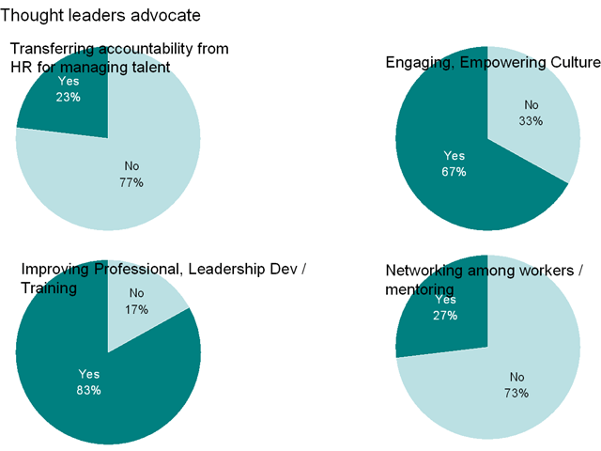

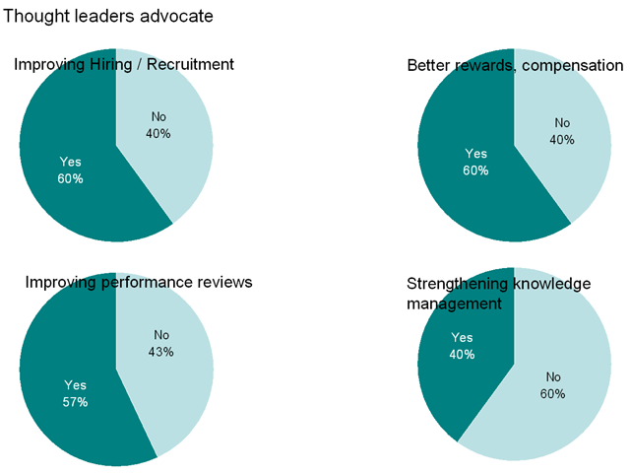

Compensating Workers According to This Model

"Pay and benefits are the most easily replicated aspects of an organization’s total rewards offering. Any competitor can offer more. If pay and benefits become the sole way in which an organization differentiates itself from competitors, it runs the risk of overinflating its total compensation expenditure — without necessarily ever creating an engaged workforce." ⁽²⁶⁾

This report suggests that the reason stock options don’t motivate common workers in the same way it motivates the most senior executives is because a senior executive’s output is the success of the overall organization, which the value of the stock options directly reflect, while the output of the individual worker doesn’t directly impact the value of his options.

Thus, commission compensation structures are the only structures that work optimally with this model. (Annual salaries are grossly inefficient in this model.) Recall (from “Best Practices: Engagement and Empowerment” section) that worker compensation is tied directly to task to be completed, so by accepting a task, workers set their own compensation. Although all tasks have a minimum value and compensation, high-value tasks have graduating scales of commission compensation (rewards) tied to organizational value of a task, awarded based on varying levels of completion.

When there are multiple workers engaged in the same task for the same project, workers whose outputs are utilized divide the commission percentage based on individual assessment criteria. Regrettably, workers whose output is not selected may lament about unfairness, but since they were presented with an option to work on the task based on their own individual profiles, and they chose to do the work, fully aware of how they’d be evaluated and how a commission structure works under this model, the organization is excused from attempting to equalize commission distribution. In other words, being fair is not necessary.

Leadership, Culture, and Implementation

You may be asking yourself, “Does this report advocate decomposing leadership roles into tasks?” Yes. The difference is that leadership’s tasks are all high-value, with goals spread across longer time-frames. An organization successfully implementing the HR infrastructure described here engages approximately 25-50% (ideally fewer) of its workers in leadership roles, with the remaining workers completing tasks for different projects.

“If this organization is self-governing, what role does leadership actually play?” Leadership controls three levers in this organization: definition of value-chains, budgeting and culture.

It is leadership, with its strategic, real-time view of all opportunities and resources within the organization that is empowered with defining what can add value to the organization. The decision right to execute a project is retained by leadership, but because the organization has real-time information on the progress of a value-chain, there’s no arbitrary discretion by any executive or manager throughout the organizational hierarchy on whether to continue or terminate. If the project is a failure, it will be obvious, along with the decision to terminate it. (The decision right to set and overrule assessment criteria is retained by a governing body, such as a board of directors.)

With value defined, leadership can then authorize budgeting for projects. Because costs are transparent, in real-time by type of task and value-chain, and customized per organization (not by industry or job category), there’s no arbitrary discretion by any executive or manager throughout the organizational hierarchy here either. By authorizing initiation of a value-chain, a leader, in effect, authorizes all spending associated with the completion of that value-chain (including vendor relationships, labor costs, etc).

Due to the number of people continuously cycled through this model, it is theoretically possible for two things to occur: culture changes as workers turnover (potentially over 100% organizational turnover annually) and/or multiple cultures can exist simultaneously across entire organization depending on value-chains being executed. By defining value, leadership also influences the type of “culture” adopted by workers engaged in completing a value chain.

“How can I transform an organization, steeped in its paternal culture, and suddenly empower workers to depend on themselves?” By tiering. There are two ways to execute tiering: launching a new organization/division from scratch utilizing this model or transitioning selected jobs, departments, and/or divisions to this model. It is not recommended that a sudden transformation occur, which risks losing all institutionalized knowledge before capturing it. As new workers enter your transforming organization, the organization will have multiple classes of workers – tiered – which will gradually take on new tasks, not jobs.

“The Department of Labor or some other group would have a field day with this. How does this model work in the real world of ‘arcane’ employment laws?” Despite flexible scheduling (worker location agreements would be determined by organizational needs), due to investments in training and other factors, not all workers under this model can be categorized under 1099 freelance contractors. Therefore, this report is indeed advocating an organization with an exponentially larger number of W-2 workers (or full-timers).

Before you spasm from the results of your mental math to this suggestion, consider that compensating all workers (including full-timers) by the value of the task they complete and investing more heavily in training and other worker-empowerment benefits (i.e. output ownership) is more cost efficient than traditional benefits such as signing bonuses, motivational incentives, and components such as 401ks, pensions, health care, and other benefits, insurance, and taxes mandated by law. In other words, labor costs would be less while yielding greater productivity.

And since this model proposes hiring more workers, that inevitably means more jobs and income taxes for government agencies, a scenario no politician would oppose. Thus, this model is applicable under the law, and integrates a superior labor compensation model.

Conclusion

This report does not suggest that the described model and HR structures are what all workers want. In fact, not everyone is cut out for the next economy and the sort of organizational model necessary to succeed in it. The originators of “The War for Talent” even expressed concern for companies who feel that they need to treat everyone equally and “fair” because that might diminish investments in the talent with the most potential. This model presents equal opportunities, but only for those who take advantage of them, without additional prodding and coddling.
Check out our Report on diversity:
- "The Return on Investment on Hiring White Guys", http://www.alberrios.com/c/051204tradeevent4.html

What this report does suggest is that as the U.S. economy continues to shift, this is the optimal way to manage a human resource infrastructure.

All the thought leaders reviewed obviously insisted that the components of HR they presented are critical disciplines (Figure 8), however, just one suggested the way in which organizations structure their HR functions isn’t conducive to supporting new economy talent, resulting in talent being engaged in disproportionate workload than they otherwise would in an evolved HR infrastructure, such as the one presented here. Not addressing the problems within HR will detrimentally impact the bottom line of any organization fortunate enough to continue to do business in an Information Age.

Methodology

Reports, books, and articles were selected from al berrios & co. directories ⁽²⁷⁾ on three criteria: (unless otherwise noted), they were free to access online, they were published within the last 5 years, and they had “talent”, “labor”, “workforce”, “team”, “employee”, “human capital” or some related keyword in their titles or summaries.

Thought leaders can be individual author, but for the purposes of this analysis, represent the views of an entire organization, when applicable.

Note that multiple content is listed under a single thought leader, while some content is counted once per thought leader reviewed. Thought leaders with articles and books are counted once, because thought leaders’ thoughts may not have differed substantially between article and/or book and may not have made complete data accessible (via article or book).

Thought leaders with studies are separated. There were 18 studies evaluated where executives, business owners, or workers were surveyed.

If a thought leader had more than one study on the same topic, they were all counted once. If the thought leader had multiple studies on different topics, they were counted separately.

The 17 dimensions on which thought leaders were evaluated are represented in Figures A, B, and 8.

This analysis reviewed the following thought leaders (in alphabetical order):

1) Accenture - a global management consulting, tech services and outsourcing company
“The High-Performance Workforce Study 2004: Research Report”

2) al berrios & co.
“Workers' Sentiments Towards Their Jobs Study September 2004”

3) AON - committed to supporting multinational companies as they build strong, cohesive teams that transcend borders and span cultures
“The Science of Selecting Successful Sales Professionals, April 2004”

4) Bain & Co. - a global business consulting firm
a) “Wherefore Knowledge Management? 2002”

b) “Helping Knowledge Management Be All It Can Be”, Journal of Business Strategy, May/June 2002

5) Booz Allen Hamilton - a global strategy and technology consulting firm
a) “The Four Bases of Organizational DNA”, strategy+business issue 33 2005
b) “Reinhard Selten: The Thought Leader Interview”, strategy+business issue 39 2005
c) “The Value of Corporate Values”, strategy+business issue 39 2005
d) “Are You Modular or Integral?”, strategy+business issue 39 2005
e) Release: “Employees Often View Their Companies as ‘Passive−Aggressive’ or ‘Overmanaged’”, Dec 15 2003"

6) Boston Consulting Group - an international strategy and general management consulting firm
“Rules of the Game for People Businesses: Succeeding in the Economy's Highest-Growth Segment” April 2005

7) Deloitte Consulting - broad-based business consultants who specialize in integrating people issues with business strategy.
a) “It's 2008: Do You Know Where Your Talent Is? Why Acquisition and Retention Strategies Don't Work”, 2004

b) “2005 Talent Management Strategies Survey”

8) Friedman, Tom
“The World Is Flat: A Brief History of the Twenty-first Century”, 2005, Farrar, Straus and Giroux (Note: Received as gift.)

9) Hewitt Associates - a global human resources outsourcing and consulting firm
“Next-Generation Talent Management: Insights on How Workforce Trends Are Changing the Face of Talent Management 2005”

10) IBM - a global business consulting firm
“Gray matter matters: Preserving critical knowledge in the 21st century, 2003”

11) IBM
“Addressing the challenges of an aging workforce: A human capital perspective for companies operating in Europe, 2005”

12) IBM
“The capability within: The Global Human Capital Study 2005”

13) John J. Heldrich Center for Workforce Development, Rutgers - a university-based research and policy center dedicated to raising the effectiveness of the American workplace
“Americans’ Attitudes About Work, Employers, and Government” (No date)

14) John J. Heldrich Center for Workforce Development, Rutgers
“Misconceptions About Hiring Workers with Disabilities Linger Among Nation’s Employers—Demonstrating Need for Policies to Promote Understanding, Opportunity”, March 2002

15) McKinsey & Co. - helps business leaders address their greatest challenges
a) “Using branding to attract talent”, The McKinsey Quarterly, 2004 Number 3

b) “The War For Talent” 2001 (accessed through Google Print and McKinsey.com)

16) Mercer Management Consultants - one of the world’s premier corporate strategy and operations firms
“Just Rewards: Think broadly about employee rewards and how they fit the chosen business strategy”

17) Monster.com - leading online global careers network
“Monster Employment Index: Aug 05”

18) National Federation of Independent Business
“The National Small Business Poll on Training Employees 2005”

19) PA Consulting - a leading management, systems and technology consulting firm
"How can I increase performance in my team?", Jan 2005

20) Patrick J Montana, Bruce H Charnov
“Management”, Barron's Educational Series, 2000, p207 (textbook accessed through Google Print)

21) Penn State University
“Flexible Work Schedules—Who Gets Them and What are Workers Giving Up to Get Them?”, May 2000

22) Retensa - helps companies identify and prioritize their workforce challenges
Various, http://www.retensa.com/knowledgebase/index.htm

23) RHR International - the premier firm in the field of corporate psychology
“Hitting the Ground Running: Accelerating Executive Integration Sept 2002”

24) Spencer Stuart - the leading privately held, global executive search firm
“Blue Paper: Time for an outsider: Succession planning for the family business”, Feb 05

25) Towers Perrin - a global professional services firm
“The Towers Perrin Talent Report 2001: New Realities in Today's Workforce + How Leading Organizations Manage Talent”

26) Towers Perrin
“Working Today: Exploring Employees’ Emotional Connections to Their Jobs, Towers Perrin, 2003”

27) Upjohn Institute - an independent, nonprofit research organization devoted to finding, evaluating, and promoting solutions to employment-related problems
“Education and the Economy Jan 2001”

28) Upjohn Institute
“The Level and Utilization of Human Capital in the United States”, 1975–2000, April 03

29) Various Academics underwritten by Ford Foundation (found via Watson Wyatt)
“Building a Next Generation Workforce Development System”, September 2000

30) Watson Wyatt - a public, global, human capital consulting firm
"Strategic performance measurement and reward systems survey Results 2004"

About the Author

Al Berrios is Managing Director of al berrios & company inc. A trained economist, Mr. Berrios launched his firm in 2000, and has since articulated, tested, and proven ideas on building a new type of management consulting firm: every engagement utilizes fresh thinking on how professional service firms engage their staff, execute research, approach consulting, define strategy, & deliver advice. For more info, visit: alberrios.com/who/people

Notes

(1) "Re-Evaluating Your Entry Level HR Strategies", http://www.alberrios.com/c/022503.html#management

(2) Source: U.S. Department of Education, Institute of Education Sciences, National Center for Education Statistics, National Assessment of Educational Progress (NAEP), selected years, 1971–2004 Long-Term Trend Reading Assessments, http://nces.ed.gov/nationsreportcard/ltt/results2004/nat-reading-perf.asp; al berrios & co. analysis.

(3) Source: Bureau of Labor Statistics, College Enrollment and Work Activity of High School Graduates, http://www.bls.gov/news.release/hsgec.nr0.htm; al berrios & co. analysis.

(4) Source: U.S. Department of Commerce, Bureau of the Census, U.S. Census of Population, 1960, Volume 1, part 1; Current Population Reports, Series P-20 and previously unpublished tabulations; and 1960 Census Monograph, "Education of the American Population," by John K. Folger and Charles B. Nam. (This table was prepared October 2003.), http://nces.ed.gov/programs/digest/d03/tables/dt008.asp; al berrios & co. analysis.

(5) Source: U.S. Department of Education, National Center for Education Statistics, The NCES Common Core of Data (CCD), "State Nonfiscal Survey of Public Elementary/Secondary Education," various years; National Public Education Financial Survey," various years; National Elementary and Secondary Enrollment Model; and Elementary and Secondary School Current Expenditures Model. (This table was prepared July 2003.), http://nces.ed.gov/programs/projections/tables/table_33.asp; al berrios & co. analysis.

(6) Source: Bureau of Labor Statistics, College Enrollment and Work Activity of High School Graduates, http://www.bls.gov/news.release/hsgec.nr0.htm; al berrios & co. analysis.

(7) Source: Bureau of Labor Statistics, Employment status of the civilian noninstitutional population 25 years and over by educational attainment, sex, race, and Hispanic or Latino ethnicity, ftp://ftp.bls.gov/pub/special.requests/lf/aat7.txt; al berrios & co. analysis.

(8) Source: The National Small Business Poll on Training Employees 2005

(9) Source: "Number of Firms, Number of Establishments, Employment, Annual Payroll, and Receipts by Employment Size of the Enterprise for the United States and States, Totals - 2002", 2002 County Business Patterns and 2002 Economic Census; al berrios & co. analysis.

(10) The Impacts on Your Business of Increasing the Minimum Wage, Withholding Medical Benefits, and Implementing a Two-Tier Compensation, http://www.alberrios.com/c/091404management2.html

(11) Working Today: Exploring Employees’ Emotional Connections to Their Jobs, Towers Perrin, 2003

(12) Source: Bureau of Labor Statistics, Survey of Employer-Provided Training (Sept 1996); al berrios & co. analysis.

(13) Sic.

(14) "The Problem with Corporate University Training Programs in the Restaurant Industry", http://www.alberrios.com/c/0305retail.html

(15) Source: Bureau of Labor Statistics, Employment Situation Summary August 2005, http://www.bls.gov/news.release/empsit.nr0.htm, Bureau of Labor Statistics, Union Members Summary 2004, http://www.bls.gov/news.release/union2.nr0.htm

(16) al berrios & co. analysis of news reports, http://www.alberrios.com/directories/news.html

(17) Source: “The capability within: The Global Human Capital Study 2005”, IBM

(18) Source: Bureau of Labor Statistics, Survey of Employer-Provided Training (Sept 1996); PeopleReport.com estimates; al berrios & co. analysis.

(19) Greene, Jay, “Troubling Exits at Microsoft”, Business Week, September 26, 2005

(20) “Using branding to attract talent”, The McKinsey Quarterly, 2004 Number 3

(21) “Education is Bad for the Economy!”, http://www.alberrios.com/c/102103.html

(22) Source: A Work-Filled Retirement (No. 16): Workers’ Changing Views on Employment and Leisure 2005, John J. Heldrich Center for Workforce Development, Rutgers, The State University of New Jersey Center for Survey Research and Analysis, University of Connecticut

(23) sic.

(24) Source: Age Discrimination in Employment Act (ADEA) Charges, The U.S. Equal Employment Opportunity Commission, http://www.eeoc.gov/stats/adea.html; al berrios & co. analysis

(25) Source: Restricted Access (No. 14): A Survey of Employers About People with Disabilities and Lowering Barriers to Work, John J. Heldrich Center for Workforce Development, Rutgers

(26) Boston Consulting Group, "Rules of the Game for People Businesses: Succeeding in the Economy's Highest-Growth Segment" April 2005

(27) al berrios & co. Directories, http://www.alberrios.com/directories/

